Derived word

🟣 What is a Derived Word?
# Source: Chatgpt (GPT-4-turbo) at [7/24/2025]
A derived word is a word that is formed by adding a prefix or suffix (an affix) to a base word or root, which changes its meaning or grammatical category.

📘 Definition:
# Source: Chatgpt (GPT-4-turbo) at [7/24/2025]
A derived word is a new word created through derivation, a word formation process where affixes are added to a base/root word.

🔧 How Derived Words Are Formed:
# Source: Chatgpt (GPT-4-turbo) at [7/24/2025]
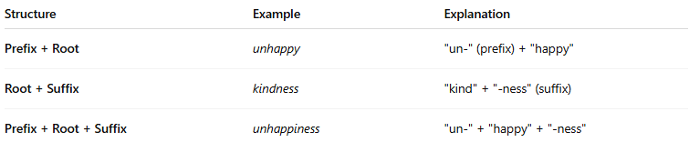
Structure | Example | Explanation
Prefix + Root | unhappy | "un-" (prefix) + "happy"
Root + Suffix | kindness | "kind" + "-ness" (suffix)
Prefix + Root + Suffix | unhappiness | "un-" + "happy" + "-ness"

✳️ Examples of Derived Words:
# Source: Chatgpt (GPT-4-turbo) at [7/24/2025]
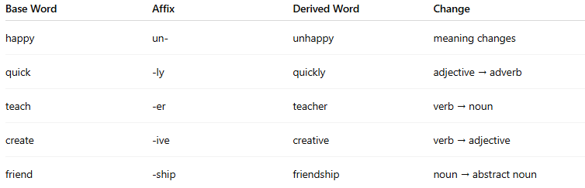
Base Word | Affix | Derived Word | Change
happy | un- | unhappy | meaning changes
quick | -ly | quickly | adjective → adverb
teach | -er | teacher | verb → noun
create | -ive | creative | verb → adjective
friend | -ship | friendship | noun → abstract noun

🧠 Derived Word vs Root/Base Word:
# Source: Chatgpt (GPT-4-turbo) at [7/24/2025]
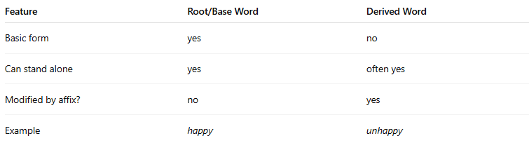
Feature | Root/Base Word | Derived Word
Basic form | yes | no
Can stand alone | yes | often yes
Modified by affix? | no | yes
Example | happy | unhappy

Derived word vs Complex word
# Source: Chatgpt (GPT-4-turbo) at [7/25/2025]
Derived word and complex word are related linguistic terms, but they are not exactly the same. Here's a clear comparison:

🔹 Derived Word
# Source: Chatgpt (GPT-4-turbo) at [7/25/2025]
- Definition: A derived word is formed by adding affixes (prefixes or suffixes) to a base or root word.
- Process: This process is called derivation (a type of morphological process).
- Purpose: Often changes the word class (e.g., noun → adjective) or meaning of the base word.
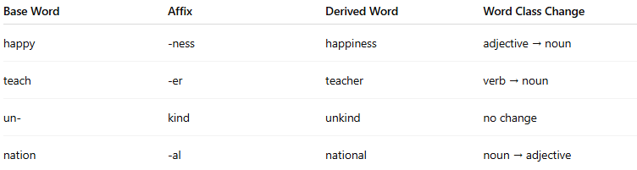
🔸 Examples:
Base Word | Affix | Derived Word | Word Class Change
happy | -ness | happiness | adjective → noun
teach | -er | teacher | verb → noun
un- | kind | unkind | no change
nation | -al | national | noun → adjective

🔹 Complex Word
# Source: Chatgpt (GPT-4-turbo) at [7/25/2025]
- Definition: A complex word is any word that consists of a base/root plus one or more affixes.
- Includes: All derived words are complex words, but not all complex words are derived in the strict sense.
- Focus: Structural — made up of more than one morpheme (root + affix(es)).
🔸 Examples:
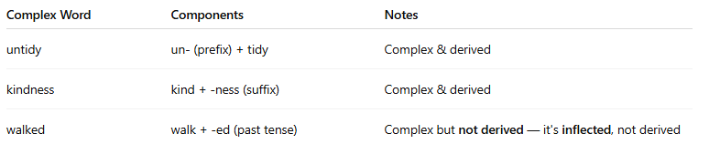
Complex Word | Components | Notes
untidy | un- (prefix) + tidy | Complex & derived
kindness | kind + -ness (suffix) | Complex & derived
walked | walk + -ed (past tense) | Complex but not derived — it's inflected, not derived

✅ Key Difference:
# Source: Chatbot (GPT-4-turbo) at [7/25/2025]
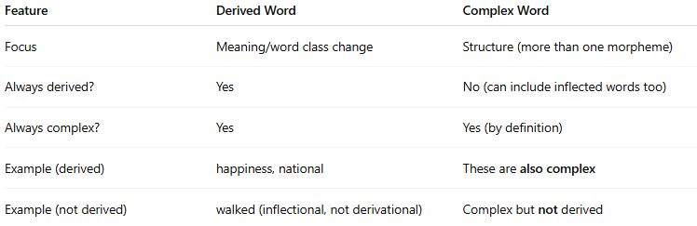
Feature | Derived Word | Complex Word
Focus | Meaning/word class change | Structure (more than one morpheme)
Always derived? | Yes | No (can include inflected words too)
Always complex? | Yes | Yes (by definition)
Example (derived) | happiness, national | These are also complex
Example (not derived) | walked (inflectional, not derivational) | Complex but not derived

💡 Summary:
# Source: Chatbot (GPT-4-turbo) at [7/25/2025]
- All derived words are complex words.
- But not all complex words are derived — some are inflected (like played, cats).

✅ Summary:
# Source: Chatgpt (GPT-4-turbo) at [7/24/2025]
A derived word is created by adding affixes to a root or base word,
resulting in a word with a new meaning or grammatical role.

